**DAX Filter context**

Total sales (US)=

                    CALCULATE ([Total Sales],

                    'Sales Territory'[Sales Territory Country] ="united states")

1.NB/ CALCULATE FUNCTION: Overrides all filters that are there and performs the calculations specified with no filters

2. NB/KEEPFILTER it maintains the filters that were present even if calculate function is used

Total sales (US) =

                    CALCULATE ([Total Sales],

                    KEEPFILTERS ('Sales Territory'[Sales Territory Country] ="united states"))

1. **How CALCULATE Works**
   * CALCULATE modifies the context of a measure.
   * In CALCULATE([Total Sales], ...), the new filter is applied before calculating [Total Sales].
2. **How KEEPFILTERS Works**
   * Normally, CALCULATE **overwrites filters** (meaning it would ignore the country filter from the table).
   * KEEPFILTERS makes sure the existing filter **stays active** while applying the additional filter (United States).

**Final Explanation**

* In the **left table**, Power BI ignores the country filter and applies "United States" for **every row**. That's why you see **$9,389,789.51 everywhere**.
* In the **right table**, the filter for each country remains active, so the "Total Sales (US) keep filters" measure only affects the "United States" row.

3. % of total sales by country =

                                DIVIDE (

                                    [Total Sales],[Total Sales (All Countries)]

                                    )

So to remove the blank rows from the above we can use **IF Function:**

Total Sales (All Countries) =

                                IF([Total Sales]=BLANK(),

                                BLANK (),

                                CALCULATE (

                                    [Total Sales],

                                    ALL (Geography [Country]),

                                    ALL ('Sales Territory'[Sales Territory Country])

                                ))

Or

Total Sales (All Countries) =

                                IF([Total Sales]=BLANK(),

                                BLANK(),

                                IF(

                                    ISFILTERED(Geography[Country]),BLANK(),

                                CALCULATE(

                                    [Total Sales],

                                    ALL('Sales Territory'[Sales Territory Country])

                                )))

1. % of total sales by country =

                                DIVIDE(

                                    [Total Sales],[Total Sales (All Countries)]

                                    ))

**TIME INTELLIGENCE ANALYSIS**

**1.Calculating last year sales (prior year):**

Total Sales (PY) =

                    CALCULATE (

                        [Total Sales],

                        SAMEPERIODLASTYEAR('Date'[Date])

                        )

Or you can use ADDDATE Function

**2.Calculating last 2 year sales (if its 2024 we look the prior year sales for 2022):**

**//here is where the ADDDATE Fuction has advantage over SAMEPERIODLASTYEAR. Since you can decide to go back whith whatever number of DAYS,MONTHS OR YEARS you like**

Total Sales (PY) date add function =

                    CALCULATE (

                        [Total Sales],

                        DATEADD('Date'[Date], -2, YEAR)

                        )

1. **Year To Date function (YTD):**

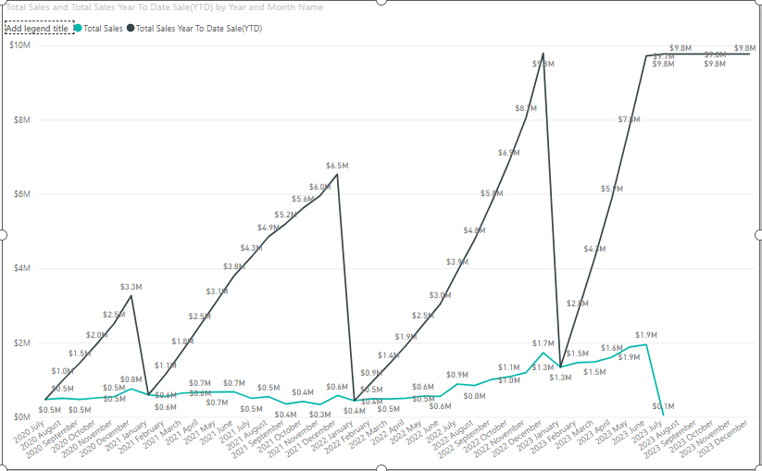

Total Sales Year To Date Sale (YTD) =

                                    CALCULATE (

                                        TOTALYTD (

                                        [Total Sales],

                                        'Date'[Date]

))

**When we use a filter context for easier understanding by picking on 2023 sales:**

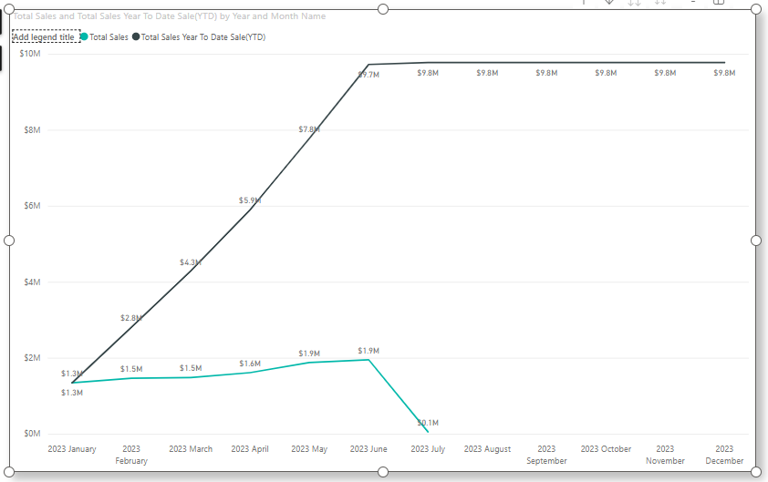

**1️ Understanding the Two Lines in the Chart**

* **Black Line** → **Total Sales Year-To-Date (YTD)**
  + This shows the cumulative sales up to that month.
  + Each month's value includes all previous months' sales for 2023.
* **Blue Line** → **Total Sales (Monthly)**
  + This shows the sales for **each individual month**.
  + The value resets every month based on that month’s sales.

**2️ Step-by-Step Breakdown of the Chart**

The **x-axis** represents **months in 2023**, and the **y-axis** represents sales in millions ($M).

**January 2023**

* **Total Sales (Blue Line)** → $1.3M (Sales for January only)
* **YTD Sales (Black Line)** → $1.3M (Since January is the first month, YTD = Total Sales)

**February 2023**

* **Total Sales** → $1.5M (February sales alone)
* **YTD Sales** → $1.3M (Jan) + $1.5M (Feb) = **$2.8M**

**March 2023**

* **Total Sales** → $1.5M
* **YTD Sales** → $2.8M (Jan & Feb) + $1.5M = **$4.3M**

**April 2023**

* **Total Sales** → $1.6M
* **YTD Sales** → $4.3M + $1.6M = **$5.9M**

**May 2023**

* **Total Sales** → $1.9M
* **YTD Sales** → $5.9M + $1.9M = **$7.8M**

**June 2023**

* **Total Sales** → $1.9M
* **YTD Sales** → $7.8M + $1.9M = **$9.7M**

**July 2023 (Unusual Drop)**

* **Total Sales** → $0.1M (Big drop in sales this month)
* **YTD Sales** → $9.7M + $0.1M = **$9.8M**

**August–December 2023**

* **Total Sales** → No sales recorded (possibly no data yet or filtering issue).
* **YTD Sales** → Stays at **$9.8M**, since no additional sales are recorded.

**3️ Why Did July 2023 Drop?**

* The **Total Sales (Blue Line) in July dropped significantly to $0.1M**, while previous months had around $1.5M–$1.9M.
* The **YTD (Black Line) still increases**, but only slightly (from $9.7M to $9.8M).
* Possible reasons:
  + Sales were unusually low in July.
  + There could be missing or incorrect data.
  + The filter may be excluding some transactions.

**4️ Summary of How YTD Works**

1. **YTD keeps adding sales from previous months**, building up the total over time.
2. If a month has **low or zero sales**, YTD only grows slightly.
3. If a month has **no data**, YTD remains **flat** (as seen from August to December).
4. **Total Sales Year To Date Prior Year**

Total Sales YTD(PY) =

                    CALCULATE(

                        [Total Sales Year To Date Sale(YTD)],

                        SAMEPERIODLASTYEAR('Date'[Date]))

If we filter only for 2023 this is the output

